



SRM INSTITUTE OF SCIENCE AND TECHNOLOGY

**FACULTY OF ENGINEERING & TECHNOLOGY**

(Formerly SRM University, Under section 3 of UGC Act, 1956)

**S.R.M. NAGAR, KATTANKULATHUR - 603 203, KANCHEEPURAM DISTRICT**

SCHOOL OF COMPUTING

DEPARTMENT OF NETWORKING AND COMMUNICATIONS

**Course Code:** 18CSE305J

**Course Name:** Artificial Intelligence

# Course Project

**Title: FAKE CURRENCY DETECTION**

# Team Members:

## 1. RA1911030010031 – MURALIDHARAN M

2. RA1911030010005 – KESHAV BALAJI BABU

## 3. RA1911030010016 – SIRPHY S

## 4. RA1911030010028 – VRUSHAL NEDUNGADI

**Date:** 11/04/2022



# Title: FAKE CURRENCY DETECTION

**Problem Statement:**

Fake Currency Detection is a real problem for both individuals and businesses. Counterfeiters are constantly finding new methods and techniques to produce counterfeit banknotes, which are essentially indistinguishable from real money. At least for the human eye.

Some of the ill-effects that counterfeit money has on society include:

* Companies are not being reimbursed for counterfeits. This has led to companies losing buying power. As such, there is a reduction in the value of real money.
* Increase in prices (inflation) due to more money getting circulated in the economy—an unauthorized artificial increase in the money supply.
* A decrease in the acceptability (satisfactoriness) of money—payees may demand electronic transfers of real money or payment in another currency (or even payment in precious metals such as gold).

At the same time, in countries where paper money is a small fraction of the total money in circulation, the macroeconomic effects of counterfeiting of currency may not be significant. The microeconomic effects, such as confidence in the currency, however, may be large.

In modern times, more sophisticated anti-counterfeiting systems such as holograms, multi-colored bills, embedded devices such as strips, raised printing, microprinting, watermarks, and color-shifting inks, etc. are used. But still there is a large number of counterfeit money being circulated around.

An example of anti-counterfeiting measures used by the government while printing money can be seen in the 2000₹ notes printed by RBI in India –

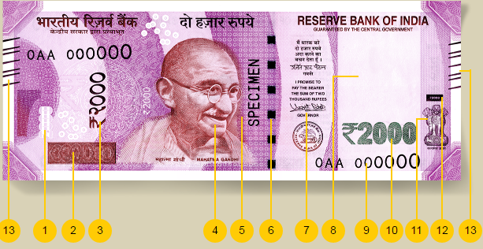

1. See through Register
2. Latent image
3. Denominational numeral in Devanagari
4. Mahatma Gandhi portrait
5. Micro letters “RBI” & “2000”
6. Security thread with inscription “Bharat”
7. Guarantee clause
8. Portrait and electrotype watermark
9. Number panel
10. Denomination in numerals
11. Ashoka pillar emblem
12. Intaglio printing
13. Intaglio printing on the lines for visually impaired

The size of the note is 66mm x 166mm.

Fake Currency Detection is a task of binary classification in machine learning. If we have enough data on real and fake banknotes, we can use that data to train a model that can classify the new banknotes as real or fake.



The dataset we will use in this task for fake currency detection contains these four input characteristics:

• The variance of the image transformed into wavelets

• The asymmetry of the image transformed into wavelets

• Kurtosis of the image transformed into wavelets

• Image entropy

The target value is simply 0 for real banknotes and 1 for fake banknotes.